Prevent QR Code
Home Office Prevent training
Protect UK app
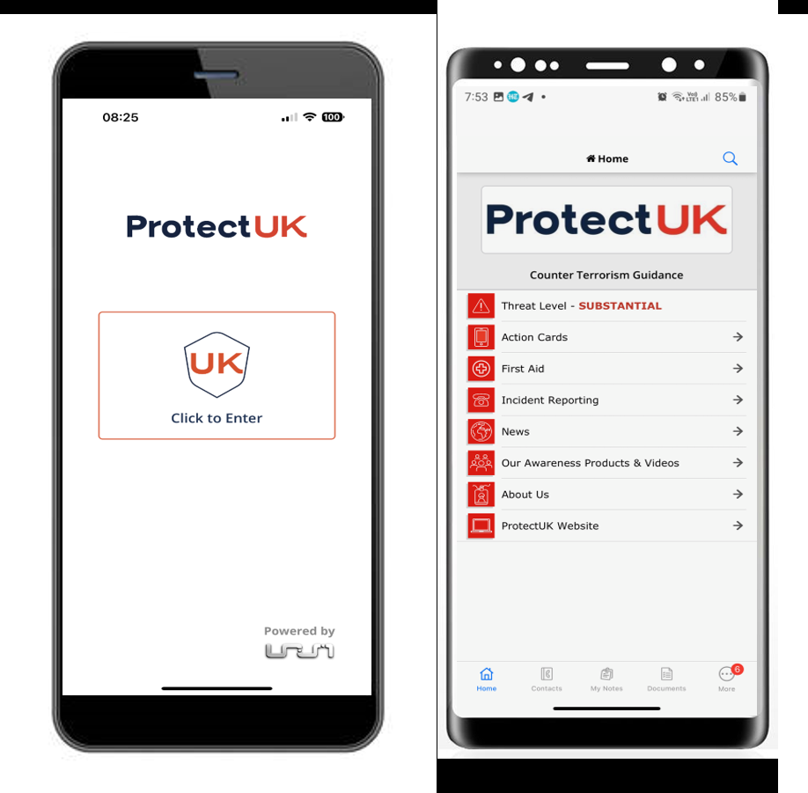

Prevent duty training - GOV.UK (www.gov.uk)

Prevent@hants.gov.uk

These are just a few resources which may be helpful
SAFEGUARDING
AGAINST
RADICALISATION

Resources

